Name: Iron Island, Lake Nipissing 46 15.971N – 79 52.656W
Wind Suitability: sheltered from south and west winds
Approach: Approach from the east and north is good water. Easy to sail in and out.
Other Comment: Anchored in sand or gravel. The island has about 10 metres height and is wooded so that there is good shelter.
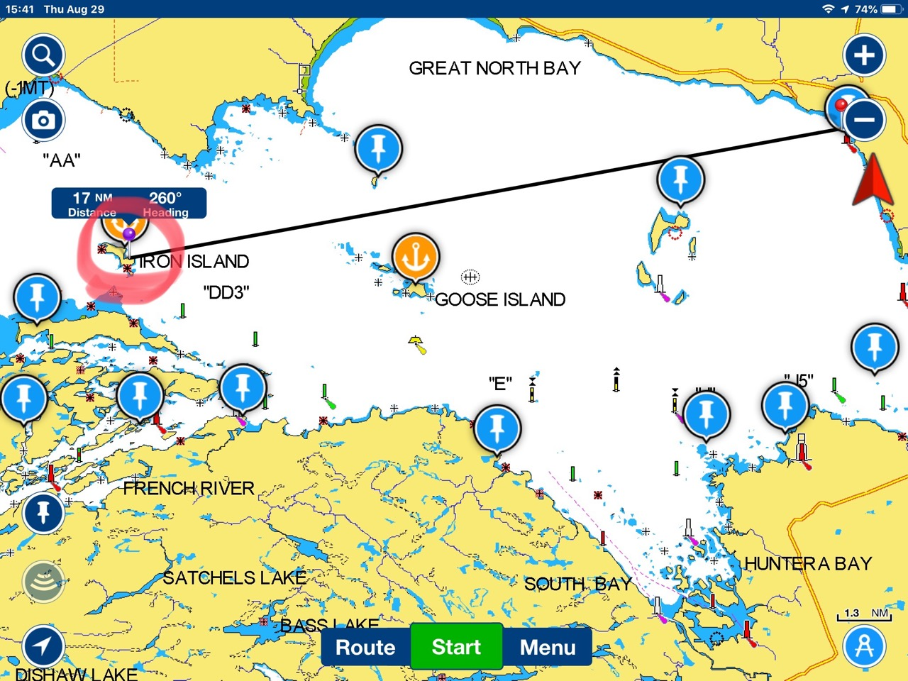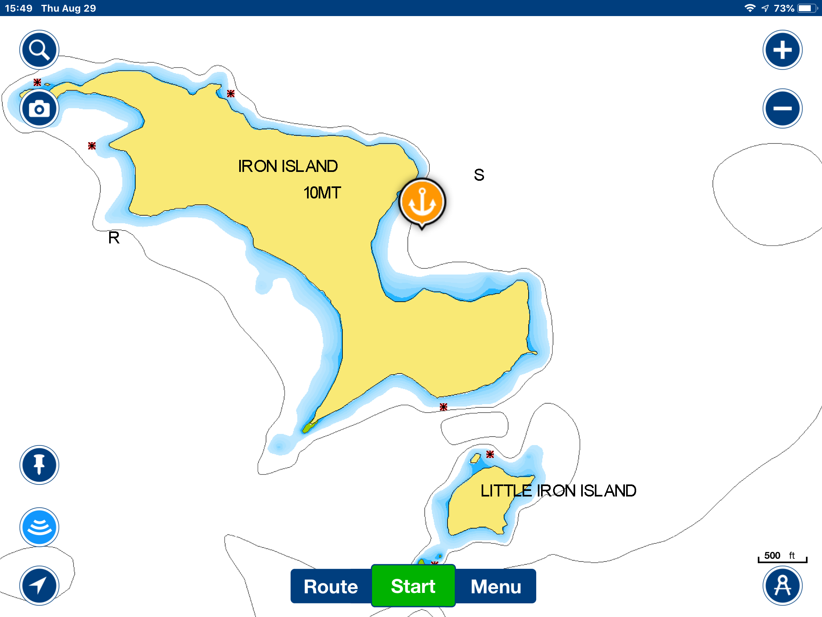
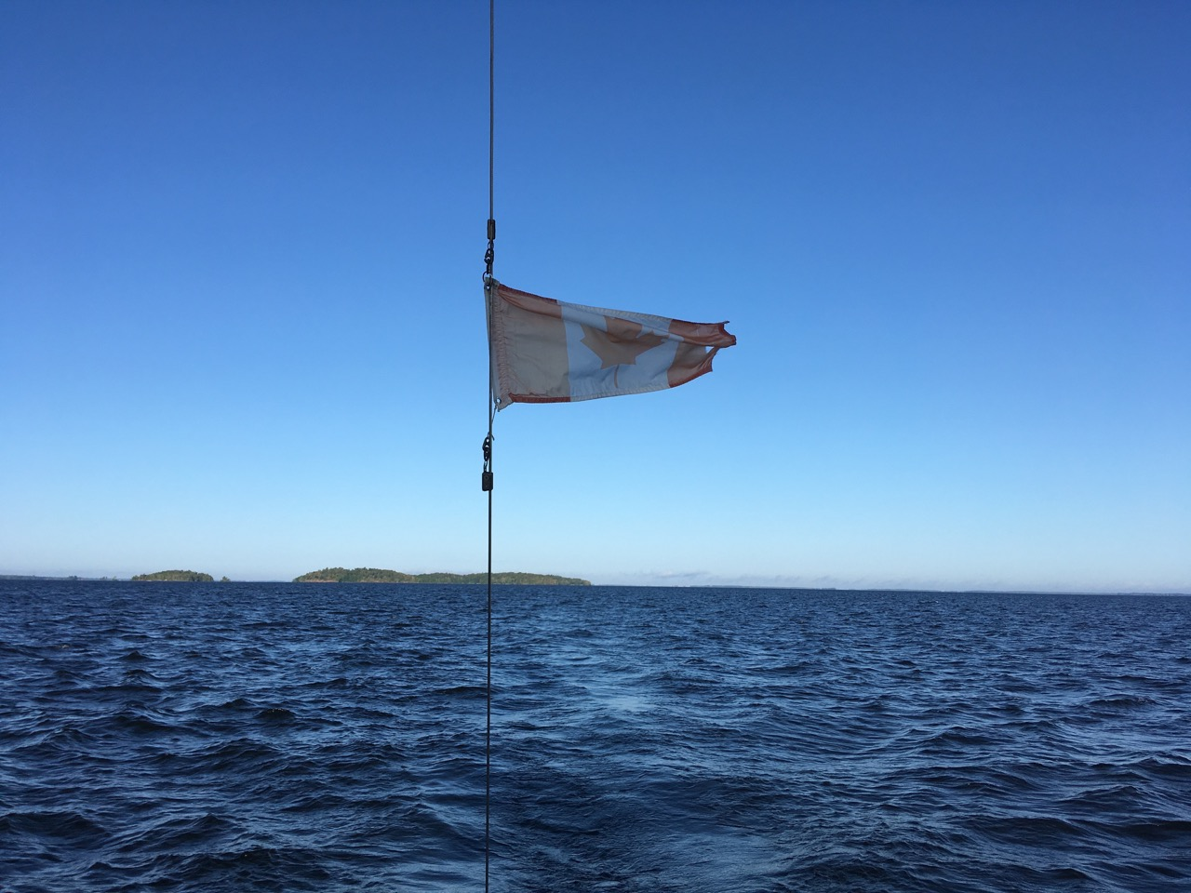 Leaving Iron Island

